**C.C.A. NOTES FORJSS 2 CONTINUATION for 1st term**

**Art Materials**

Art materials are various items that the artist uses for the production of an art work. They could be man-made or natural. There are quite a number of art materials with various examples e.g. Pencil, Paper, Ink, Ruler, Charcoal, Clay, Crayon, Dye, Plaster of Paris (POP), Starch, Canvas, Chalk, Drawing board, Sand, Poster colours, cello tape, Yarn, fabric, wood, cement, thread, rope, eraser, gum, etc.

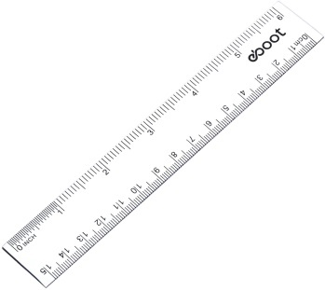 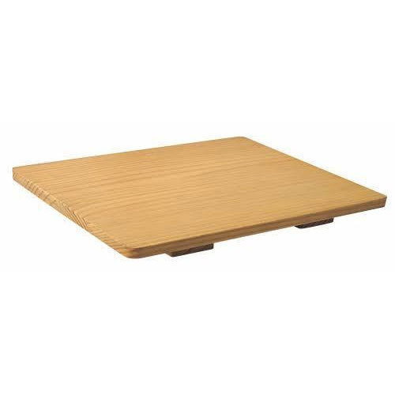 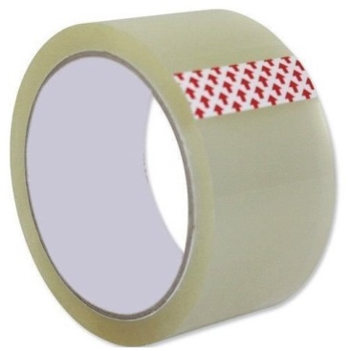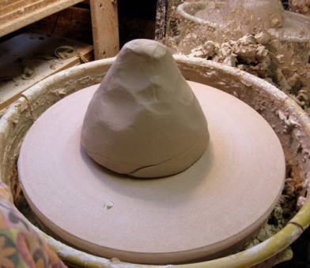 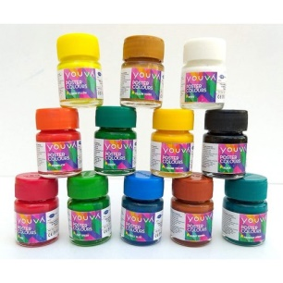

**Art Tools**

These are those instruments which the artist uses in his hand in making things. Examples of art tools are cutting tools like knife, chisel, saw, scissors, and cutter. Othersarebrush, pencil, easel, donkey kiln, scrapper, roller board, mallet, palette, lettering or calligraphic pen, palette knife, set of pastels etc. 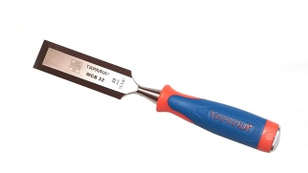 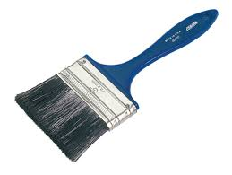 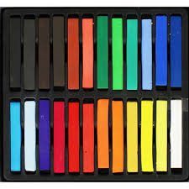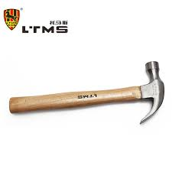 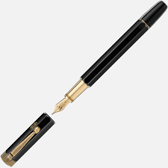 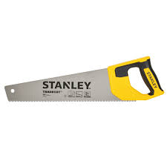

**Art Equipment**

Equipment are the instruments that are heavy which are used in art for a particular activity or purpose. Examples of Art equipment are donkey, Kiln, throwing wheel, loom, camera, welding machine, drawing table, printing table, board and easel.

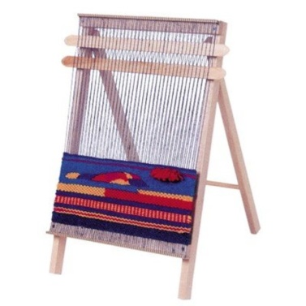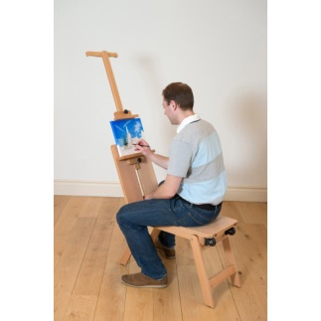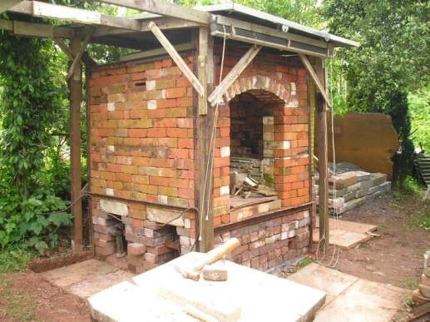

**Art Techniques**

**Elements and Principles of Art**

This simply means those ingredients concepts or ideas that make a successful artwork. A typical example is how the artist employs the elements of arts that help him produce a beautiful art work. Elements of art are also called elements of design.

**Design**

Design is the orderly arrangement or organization of elements of art to form unity. Elements of art are line, shape, colour, form, texture and space.

**Element 1:Line**

A line is a narrow mark or stroke made on a surface. When a pencil is put down on paper, a line is made. Line is said to be the basic elements of art. It is also referred to as a moving dot. Line expressed ideas and movements.

There are two majortypes of line which including:

1. Rhythmic or curved lines.

2. Structural Line

**Rhythmic or curved lines**

1. Zig-zak lines
2. Scroll Lines
3. Loop lines
4. Curved lines
5. Spiral lines
6. Wavy lines
7. Dotted lines

**Structural Line**

1. Horizontal lines
2. Diagonal or Oblique lines
3. Vertical lines

**Element 2: Shapes**

Shapes are flat two dimensional areas; it has both length and breadth (width). It could either be geometric or free form. Shapes are created with lines.

Simple geometric shapes

Complex geometric shapes are

Free form shapes: these are uneven and irregular shapes. They can be seen in many different ways. They are also made lines. They can be identified in nature, people, flower, cloud etc. below are a few examples.

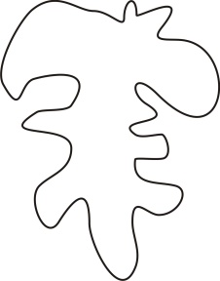 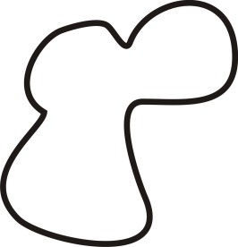 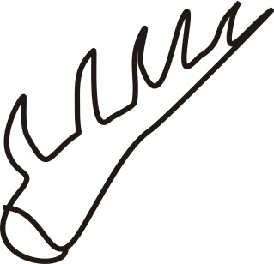

**Element 3: Space**

This is a gap or area that is not filled/occupied between two or more objects. It can be measured as the distance between or around a shape or form. Space is very important and can be considered as important as form. Artistes create space in artworks that are two dimensional (2D) and three dimensional (3D)

**Element 4: Texture**

Texture is the surface quality appearance of a material which can be felt, touched or seen with eyes. Texture could be rough, Coarse, Smooth, Furry. Every surface has a texture. You can feel the texture of an object by touching it.

**Element 5: Colour**

Colour is what is perceived when light rays reach the retina of the eyes. The reflection of light rays on an object and hitting our eyes is registered in our brains. We see through the colour of the object because of the type of light it reflects.