**C.C.A. NOTES FOR JSS 1 CONTINUATION for 1st term**

**Drawing**

Drawing is simply the ability to create picture on a surface using pencil. It is also a form of [visual art](https://en.wikipedia.org/wiki/Visual_art) in which an artist uses instruments to mark [paper](https://en.wikipedia.org/wiki/Paper) or other [two-dimensional](https://en.wikipedia.org/wiki/Two-dimensional) surface. Drawing instruments includes [pen and ink](https://en.wikipedia.org/wiki/Pen_and_ink), various kinds of [paints](https://en.wikipedia.org/wiki/Paint), [inked](https://en.wikipedia.org/wiki/Ink)[brushes](https://en.wikipedia.org/wiki/Brush), [colored pencils](https://en.wikipedia.org/wiki/Colored_pencil), [crayons](https://en.wikipedia.org/wiki/Crayon), [charcoal](https://en.wikipedia.org/wiki/Charcoal_(art)), [chalk](https://en.wikipedia.org/wiki/Sidewalk_chalk), [pastels](https://en.wikipedia.org/wiki/Pastel), [erasers](https://en.wikipedia.org/wiki/Erasers), [markers](https://en.wikipedia.org/wiki/Marker_pen), [styluses](https://en.wikipedia.org/wiki/Stylus), and metals (such as [silverpoint](https://en.wikipedia.org/wiki/Silverpoint)).

There are quite a number of drawings but we will look at basically five types

Types of drawings

1. Still Life drawing: this is the drawing of still life objects. This means objects that do not have life.

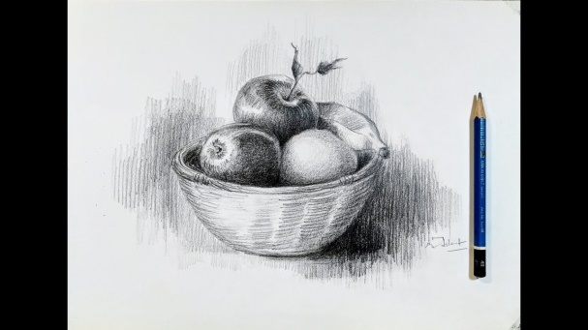

1. Life or figure drawing: this is the drawing of mostly human figures. Drawing from life figures.

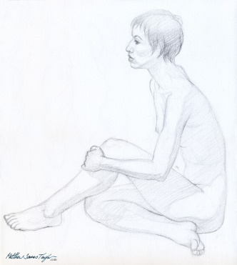

1. Nature drawing: this is a drawing related to nature.

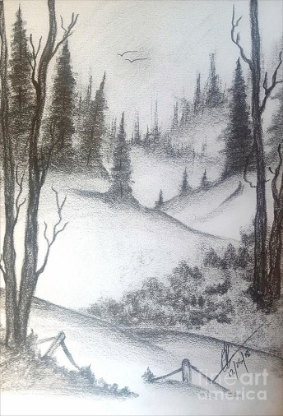

1. Landscape drawing: this is a drawing of anything related to land. It could have some trees or just a vast portion of land.

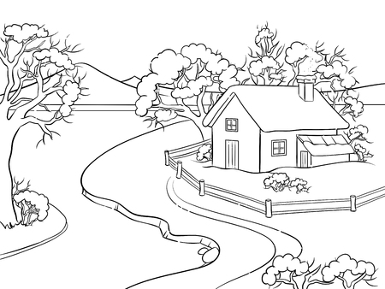

1. Imaginative drawing: this is mostly related to abstract ideas and concepts sometimes merged with real figures.

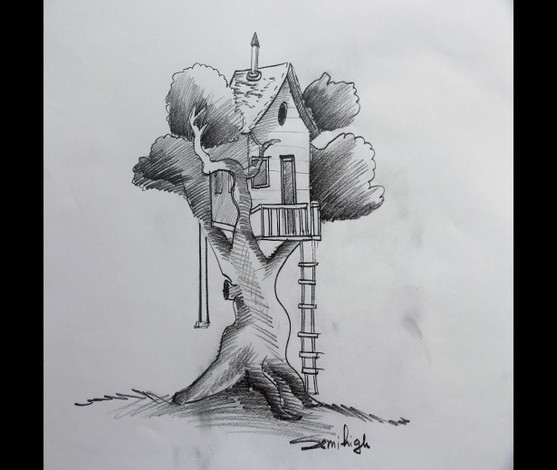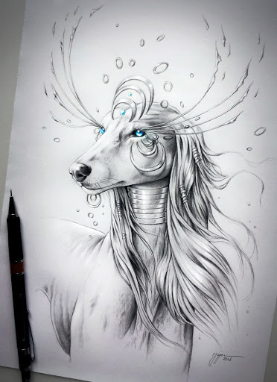

1. Seascape drawing: this is a drawing that reflects a large body of water.

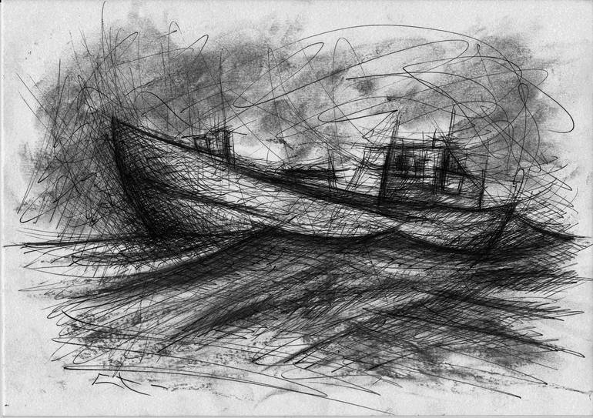

**Shading**

Shading is the reflection of light and darkness on an object either drawn or painted. It is a sip le technique that comes to live as a result of darkening parts of a drawing or painting. This helps the artist to achieve reality in any drawing also showing the direction of light.

There are four types of shading, thus:

1. Hatching

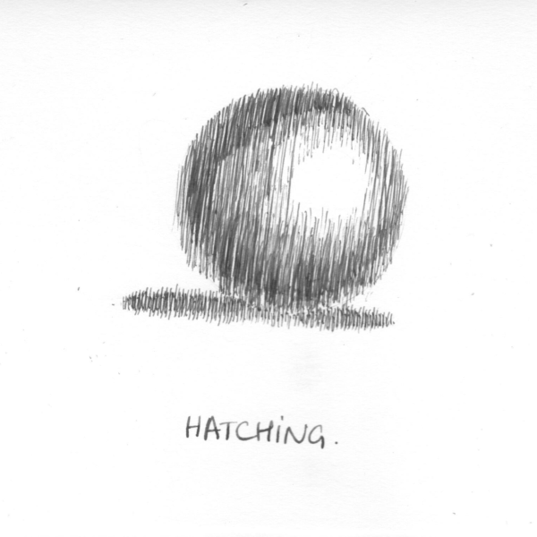

1. Cross hatching

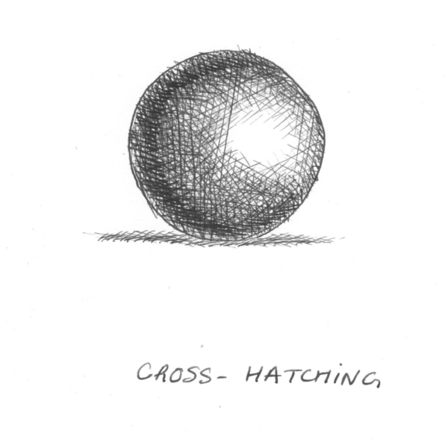

1. Blurring/ Smudging

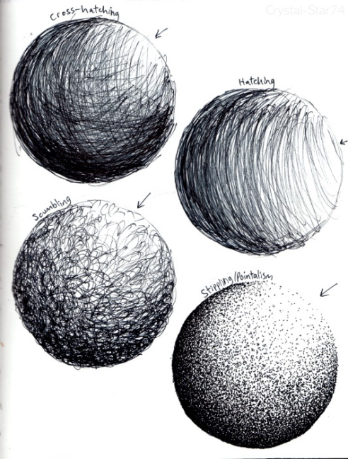

1. Pointillism

